**San Francisco Bay University**

**CE521 - Real-time Systems and Programming**

**Homework Assignment #3**

**Due day: 2/28/2022**

**Instruction:**

1. **Push the answer sheet to Github**
2. **Overdue homework submission could not be accepted.**
3. **Takes academic honesty and integrity seriously (Zero Tolerance of Cheating & Plagiarism)**
4. Install STM32CubeIDE compiler to your computer following the installation in Lab0 manual
5. Write the first program *hello* and run it in STM32CubeIDE following the instructions in the lab1 manuals

* **[ctrl+click] to follow link**

**1. Installation(LAB0)**

**2. Lab 1 – Hello World**

**3. OUTPUT**

* **INSTALLATION(LAB0) –**

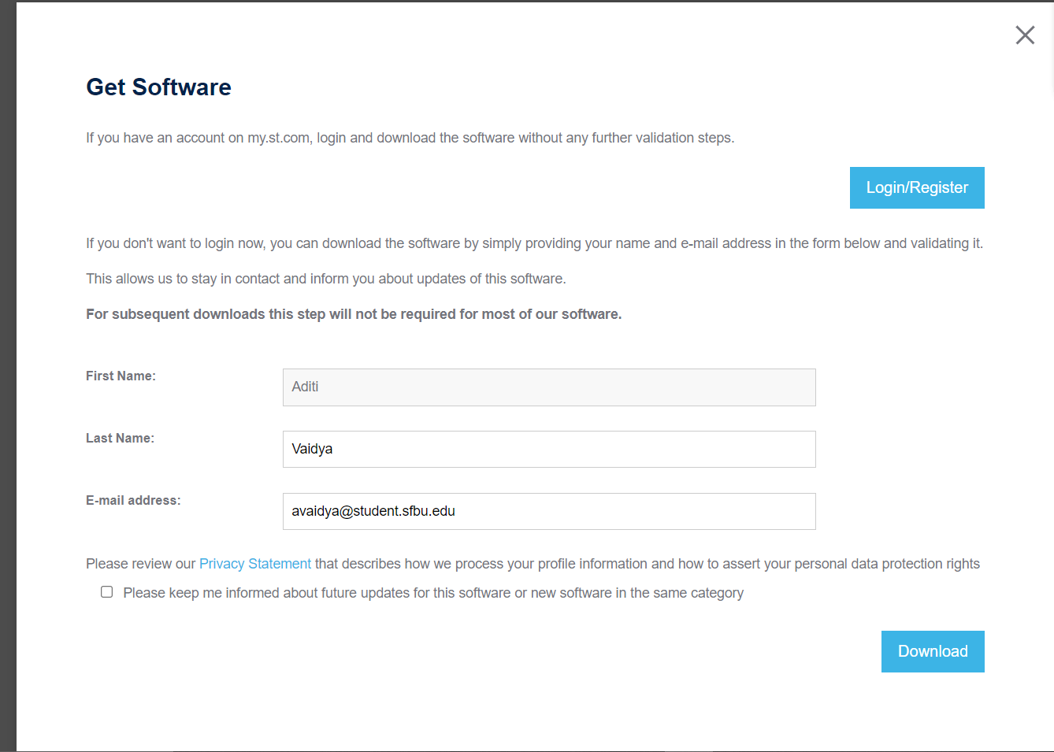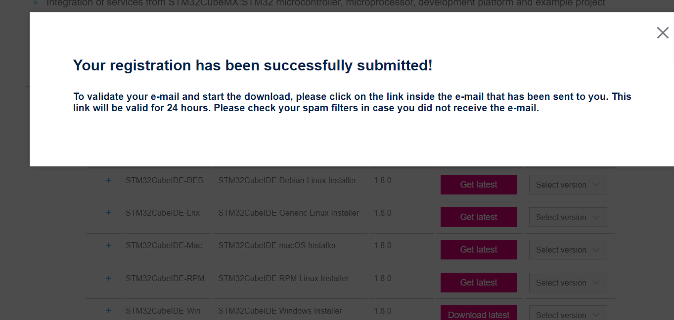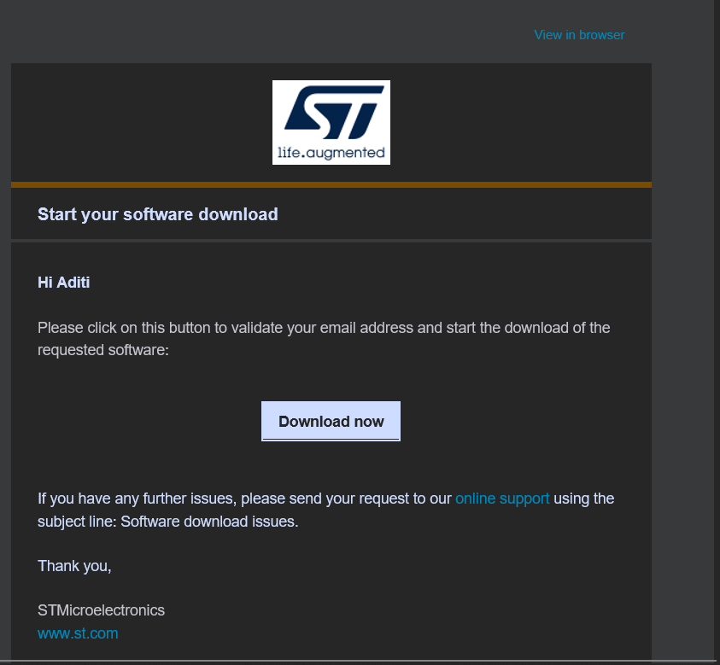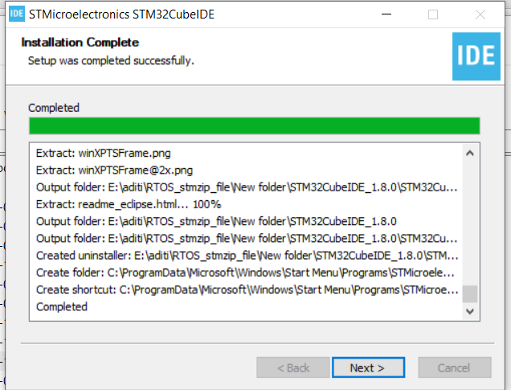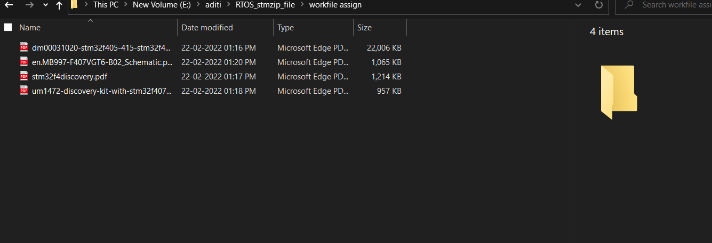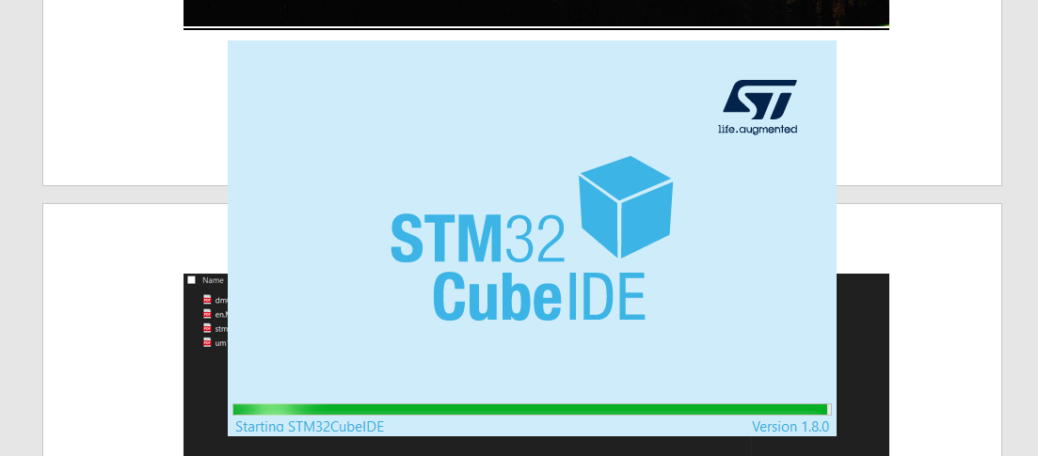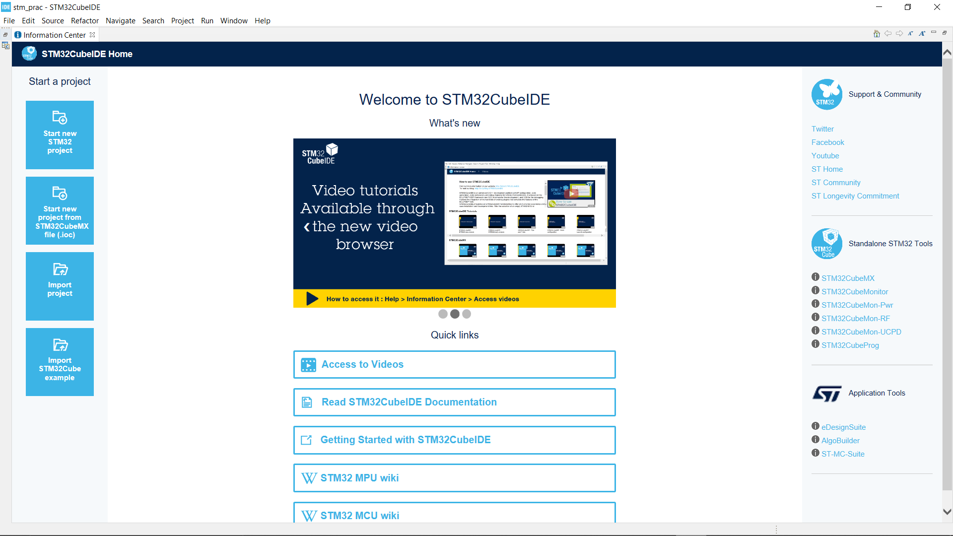

* **LAB 1 – HELLO WORLD**

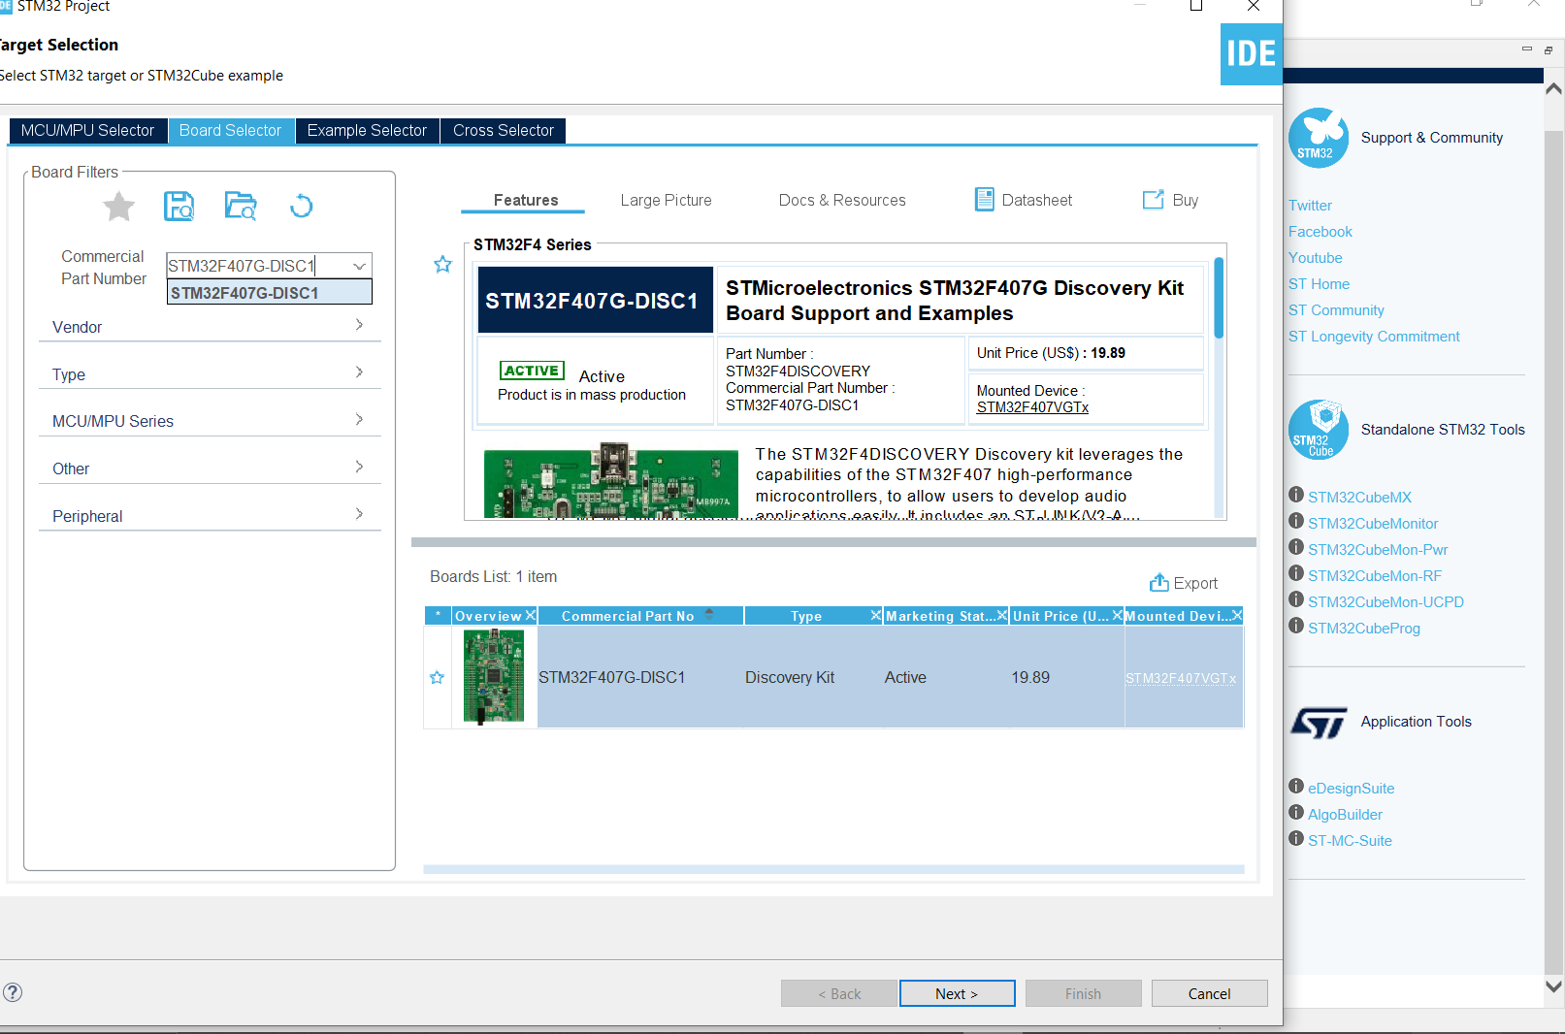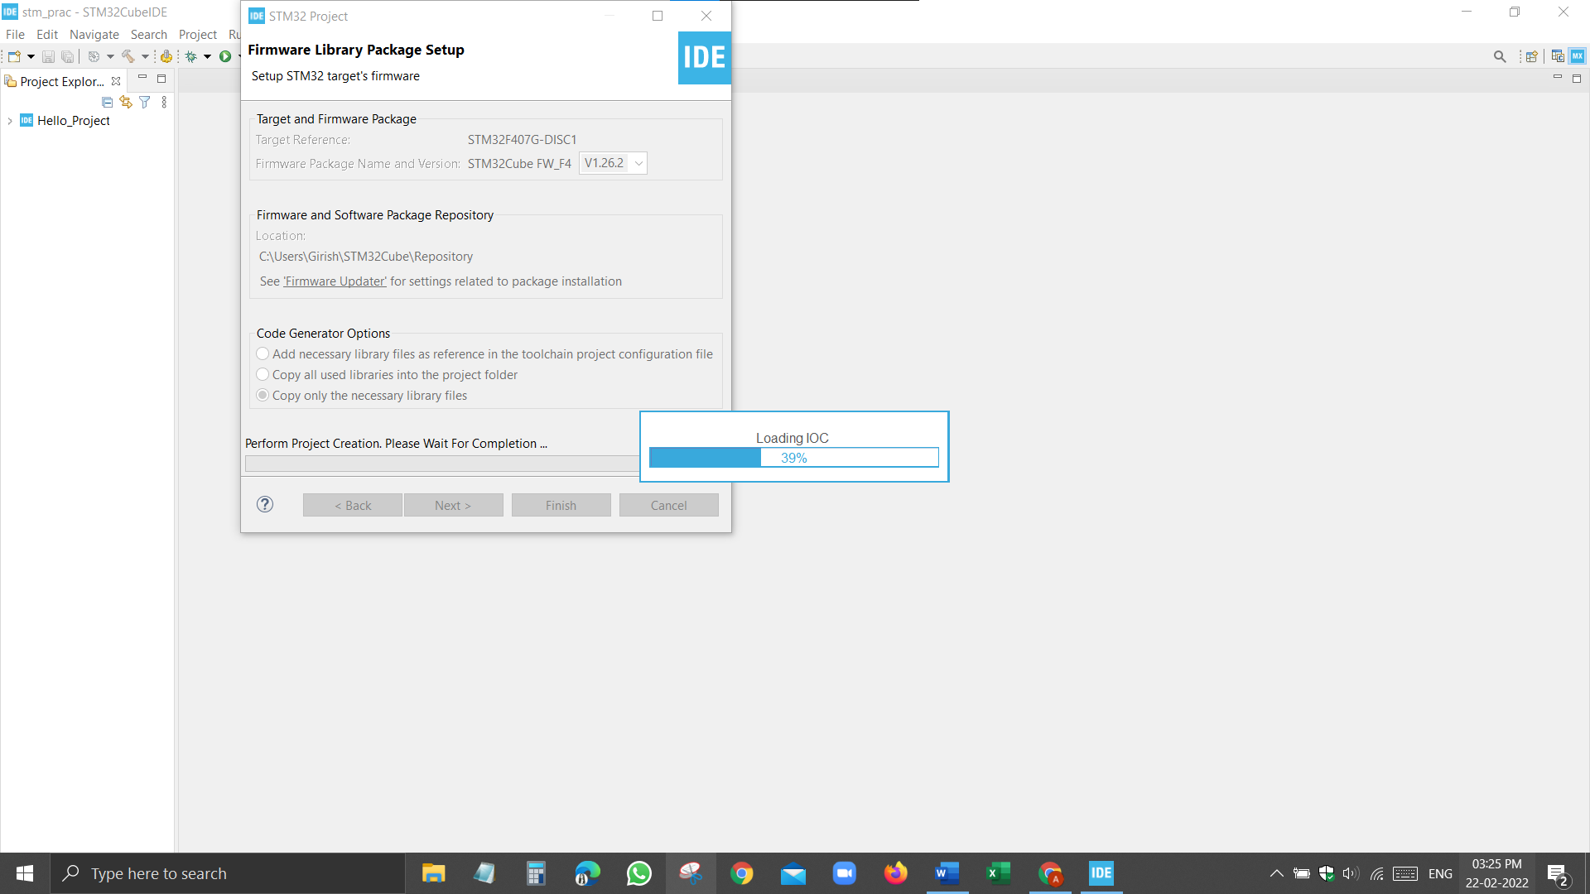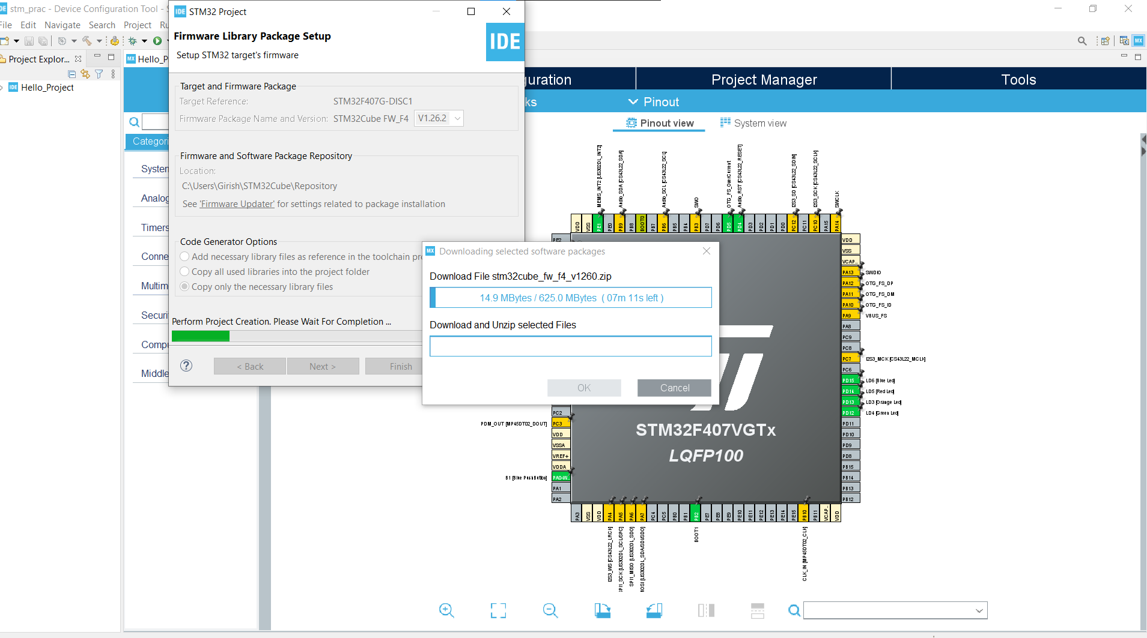 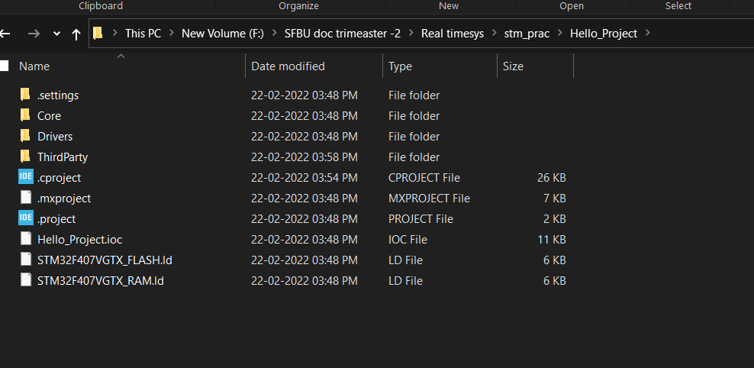 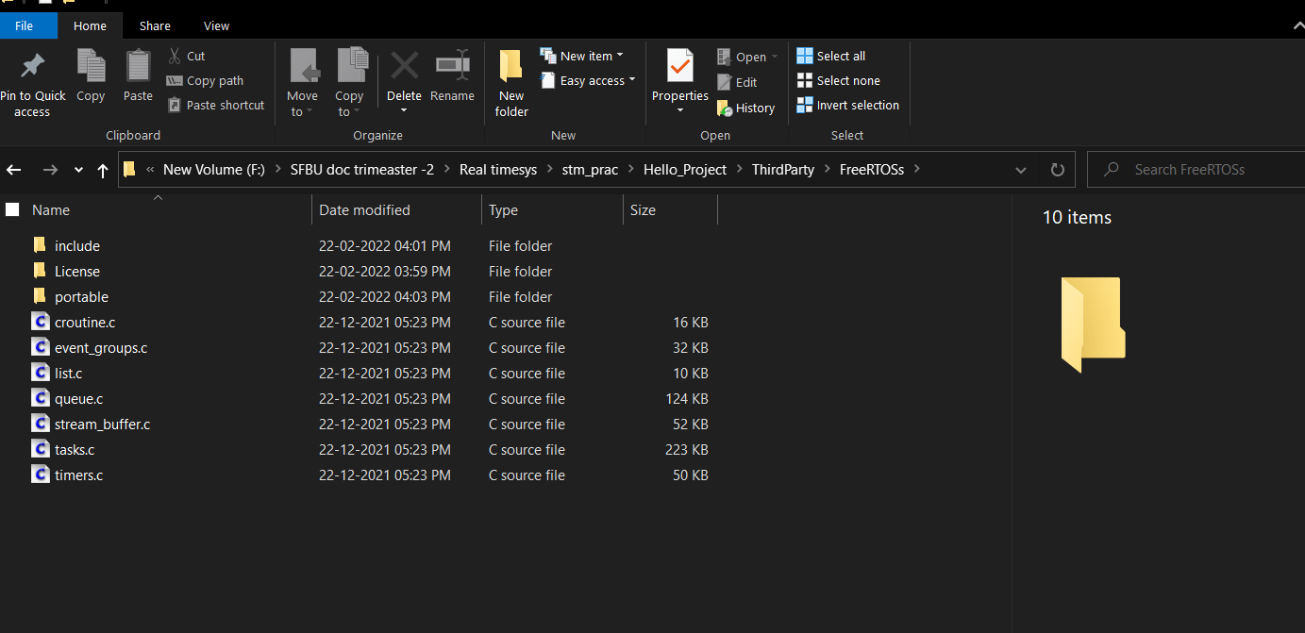 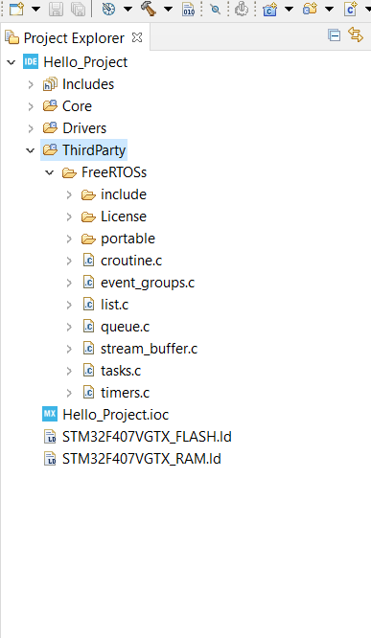 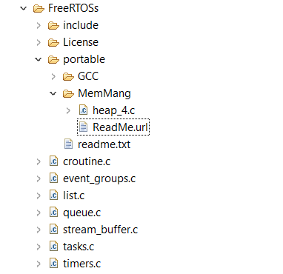 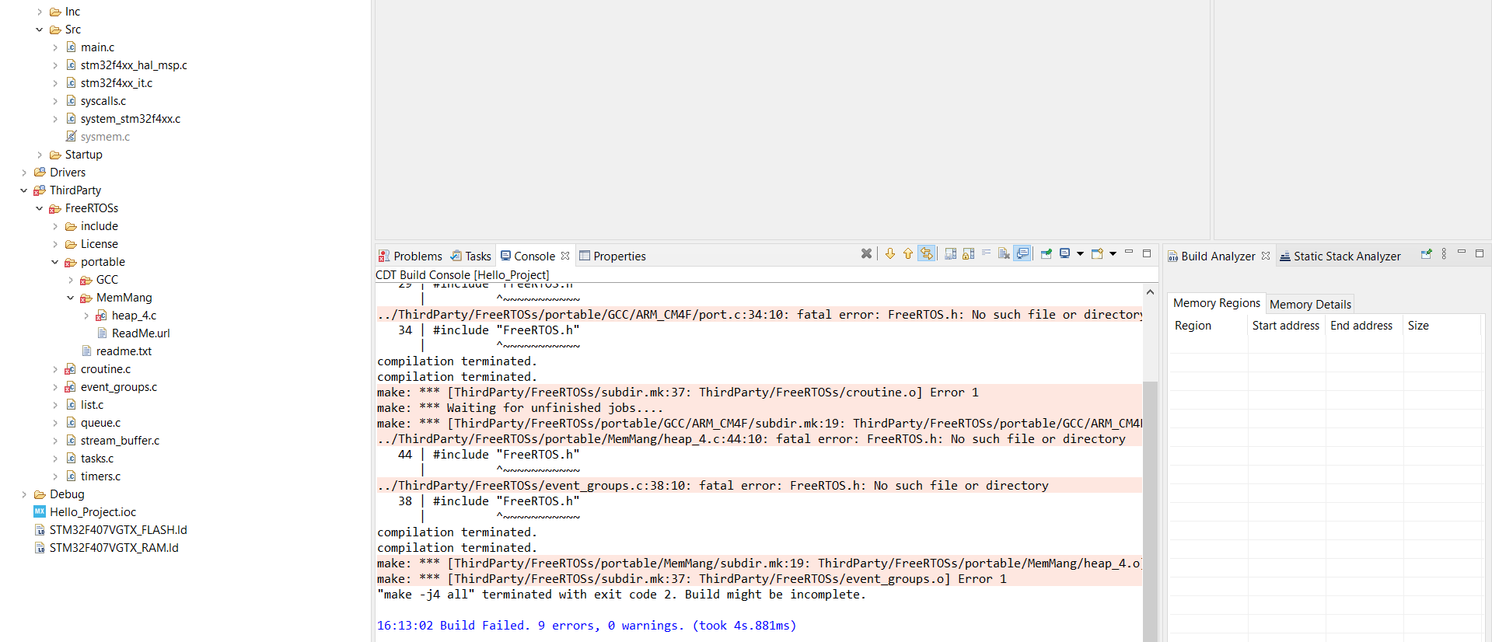 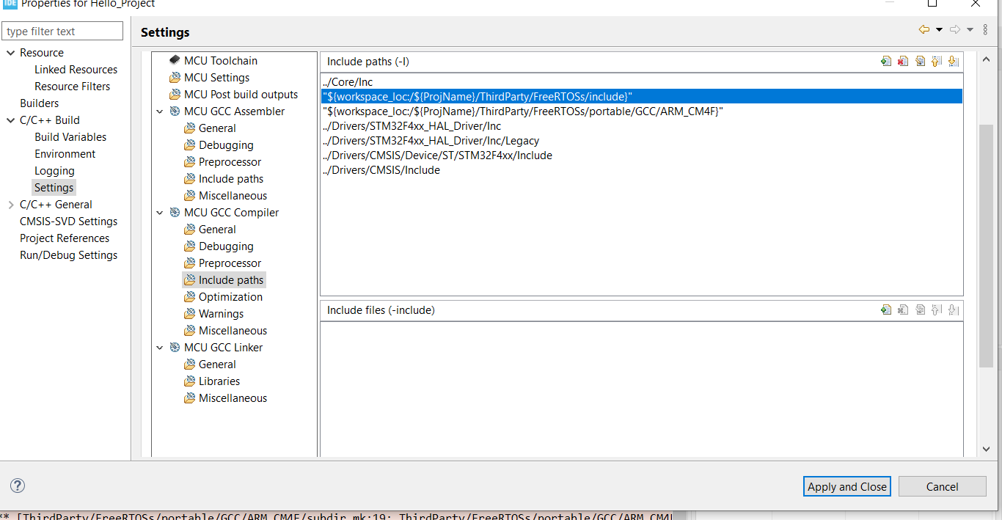 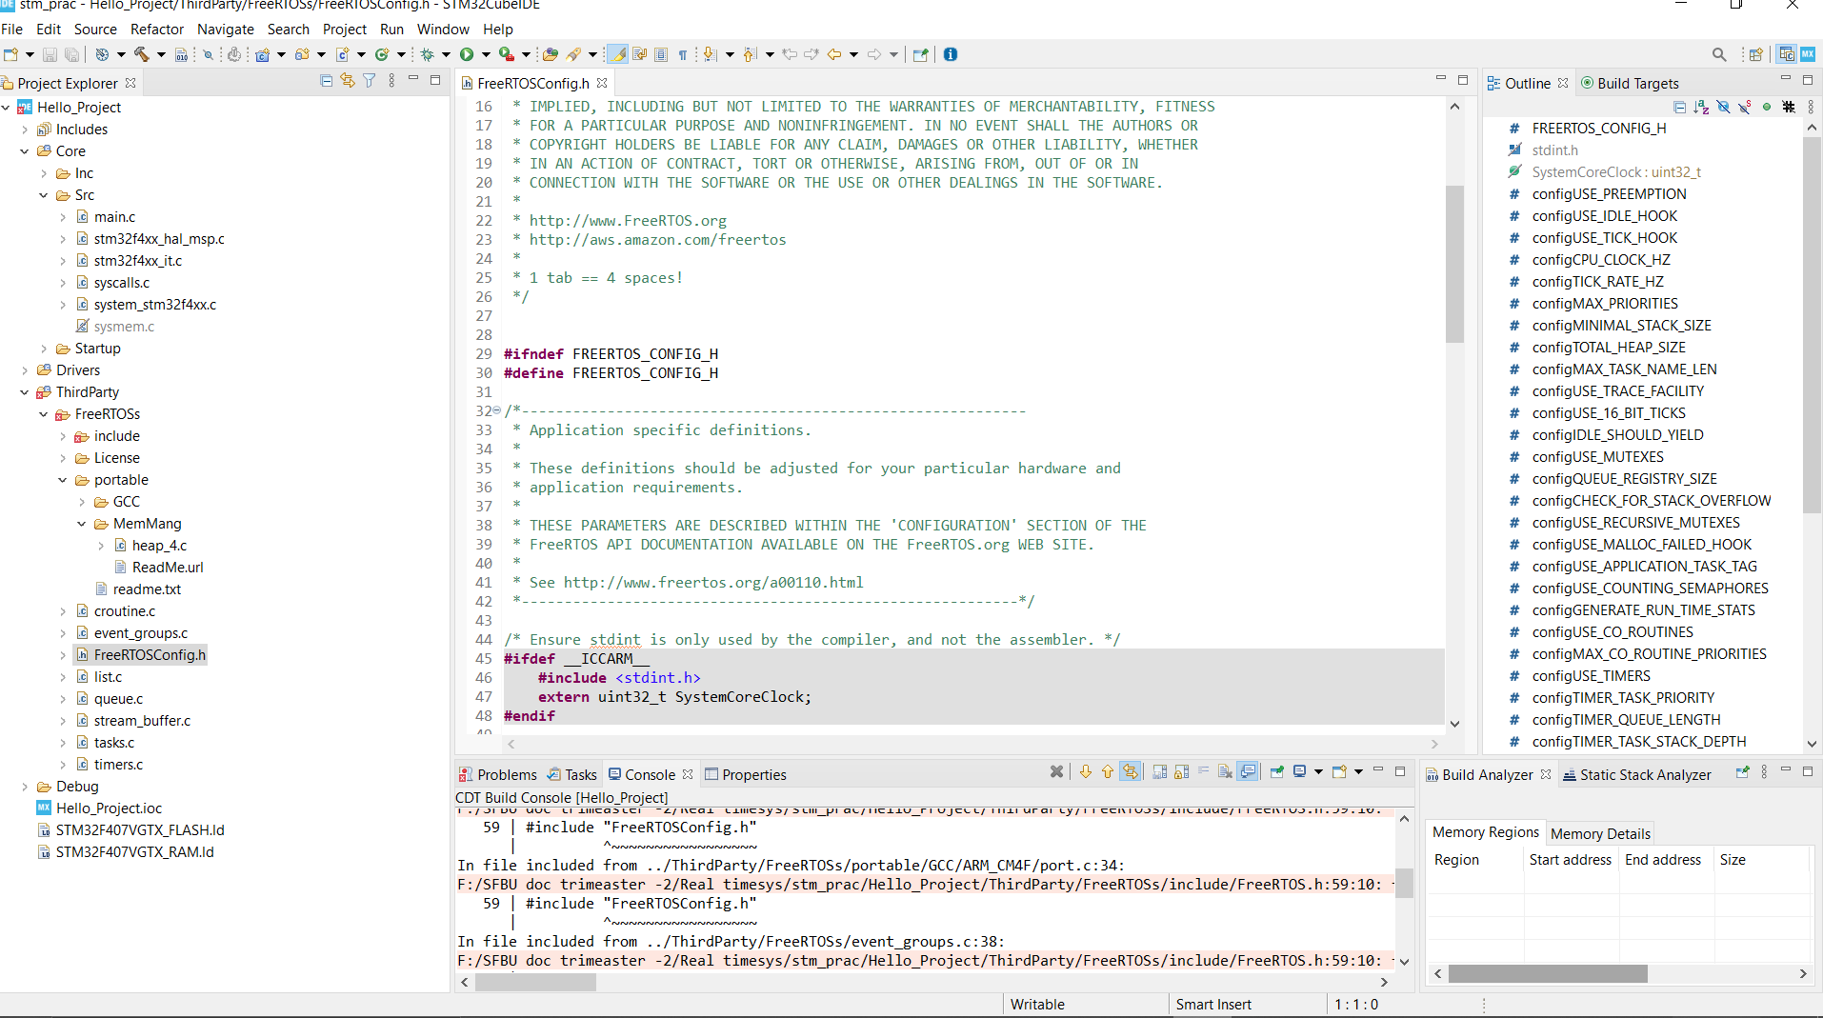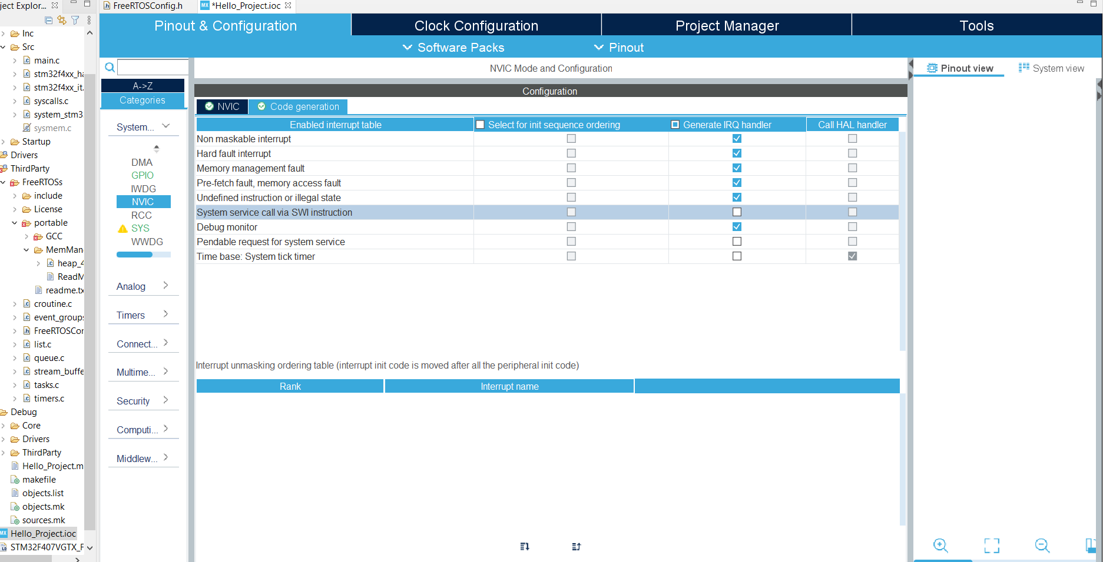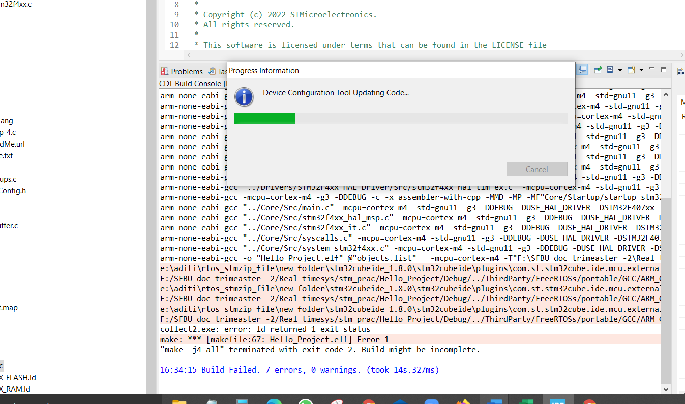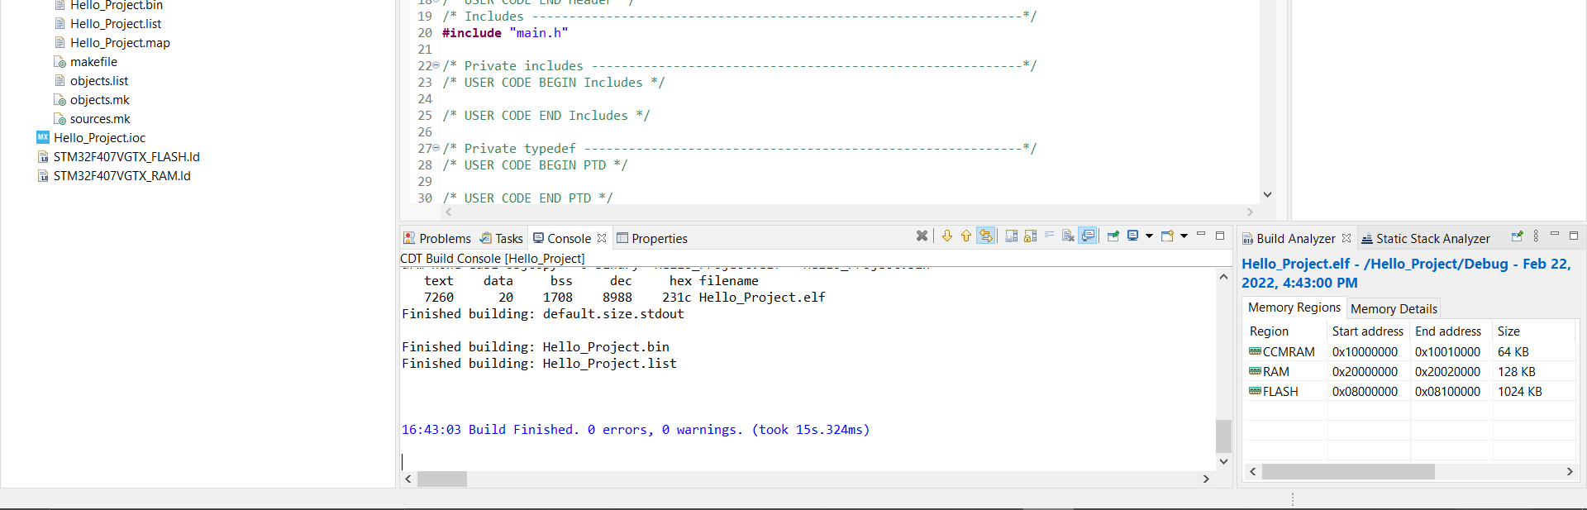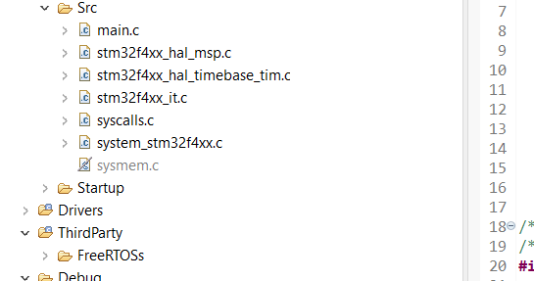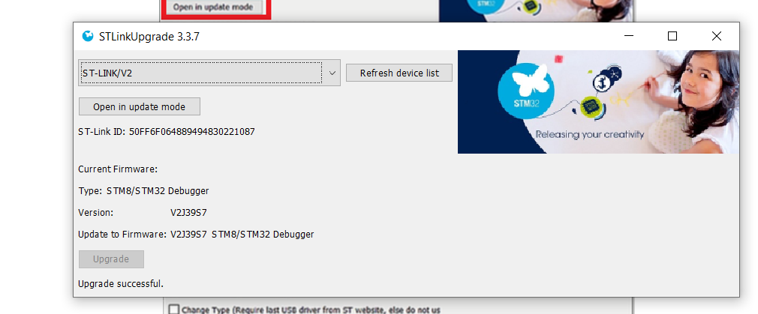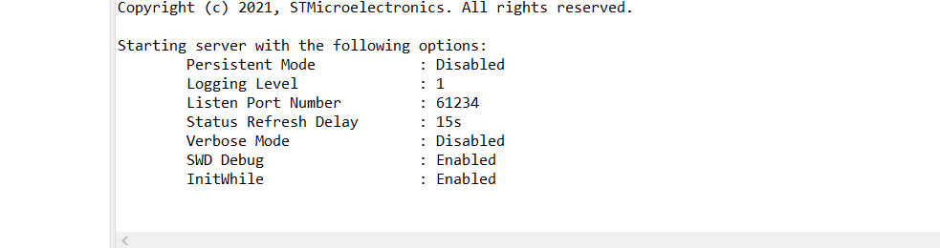

* **OUTPUT:**



